Test API by Postman

URL: <https://localhost:7123/api/HangHoa>

1. POST

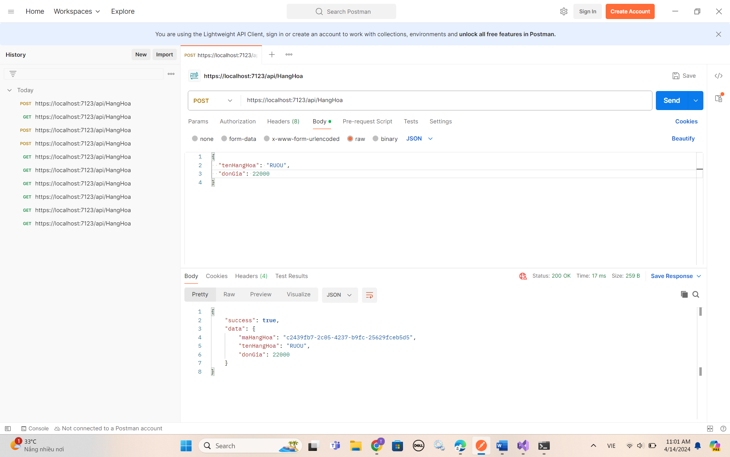

1. GET

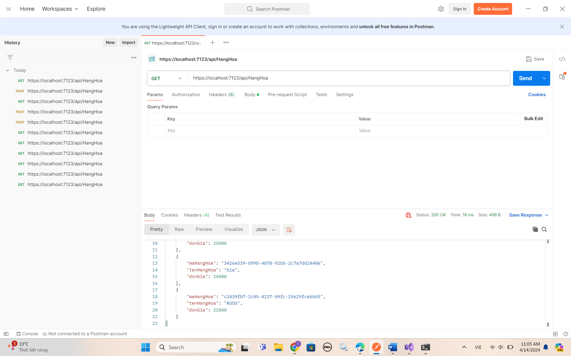

1. GET BY ID

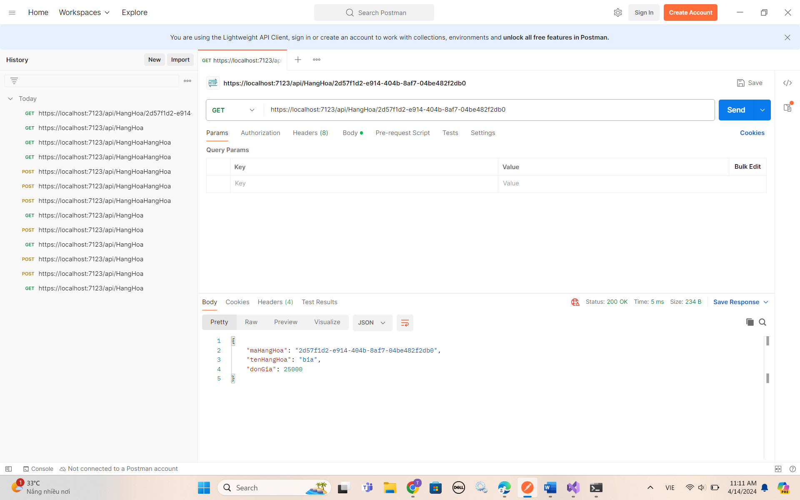

1. DELATE BY ID

